SQL Lesson 1: SELECT queries 101

1. SELECT Title FROM movies;
2. SELECT Director FROM movies;
3. SELECT Title,Director FROM movies;
4. SELECT title,year FROM movies;
5. SELECT * FROM movies;

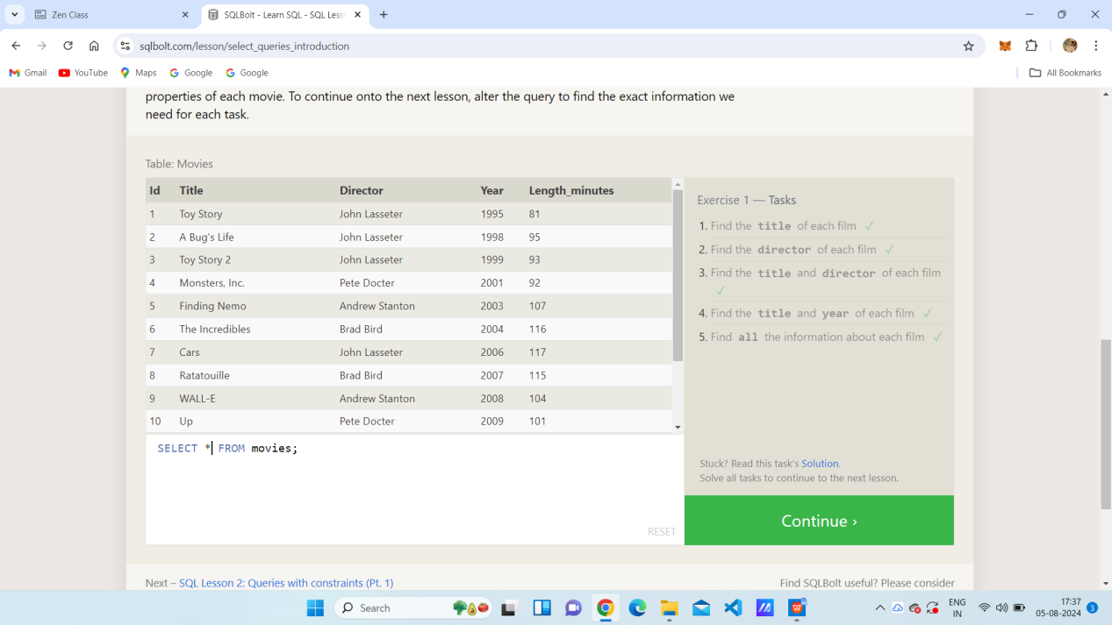

SQL Lesson 2: Queries with constraints (Pt. 1)

1. SELECT * FROM movies where id = 6;
2. SELECT * FROM movies where year between 2000 and 2010;
3. SELECT * FROM movies where year not between 2000 and 2010;
4. SELECT * FROM movies where id <=5;

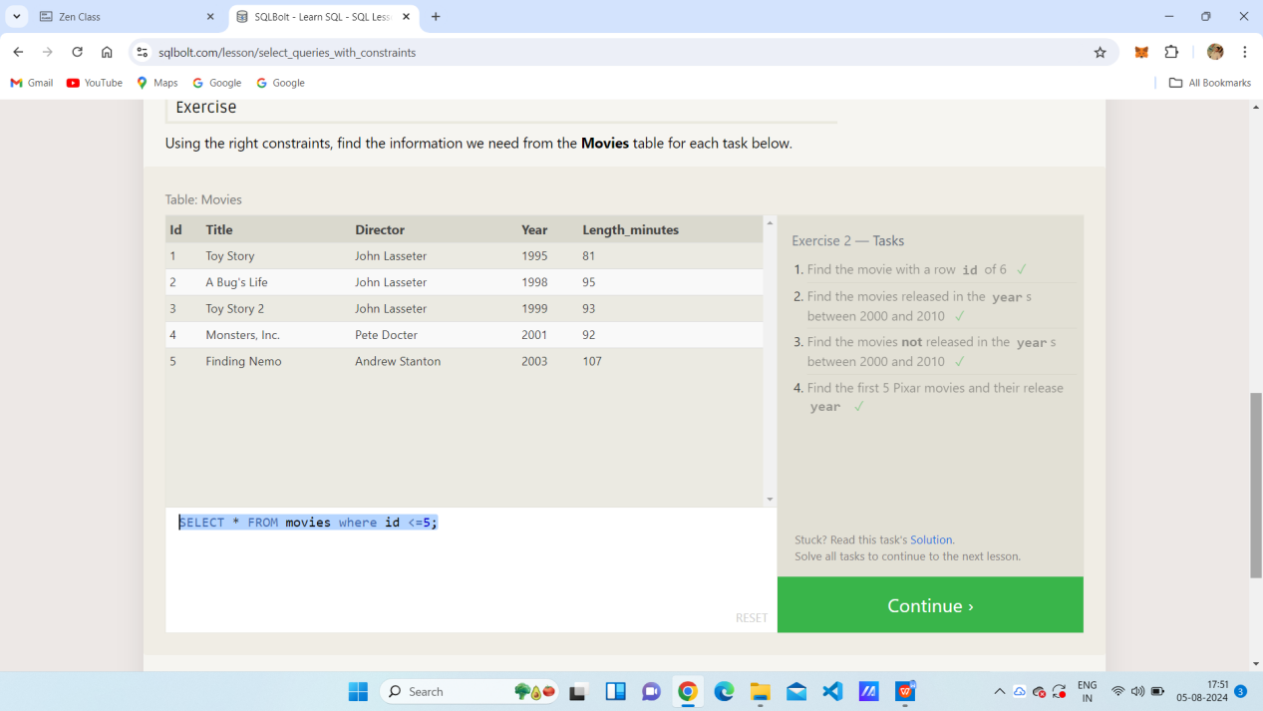

SQL Lesson 3: Queries with constraints (Pt. 2)

1. SELECT * FROM movies where title like "%toy story%";
2. SELECT * FROM movies where director like "%john lasseter%";
3. SELECT * FROM movies where director not like "%john lasseter%";
4. SELECT * FROM movies where title like "wall%";

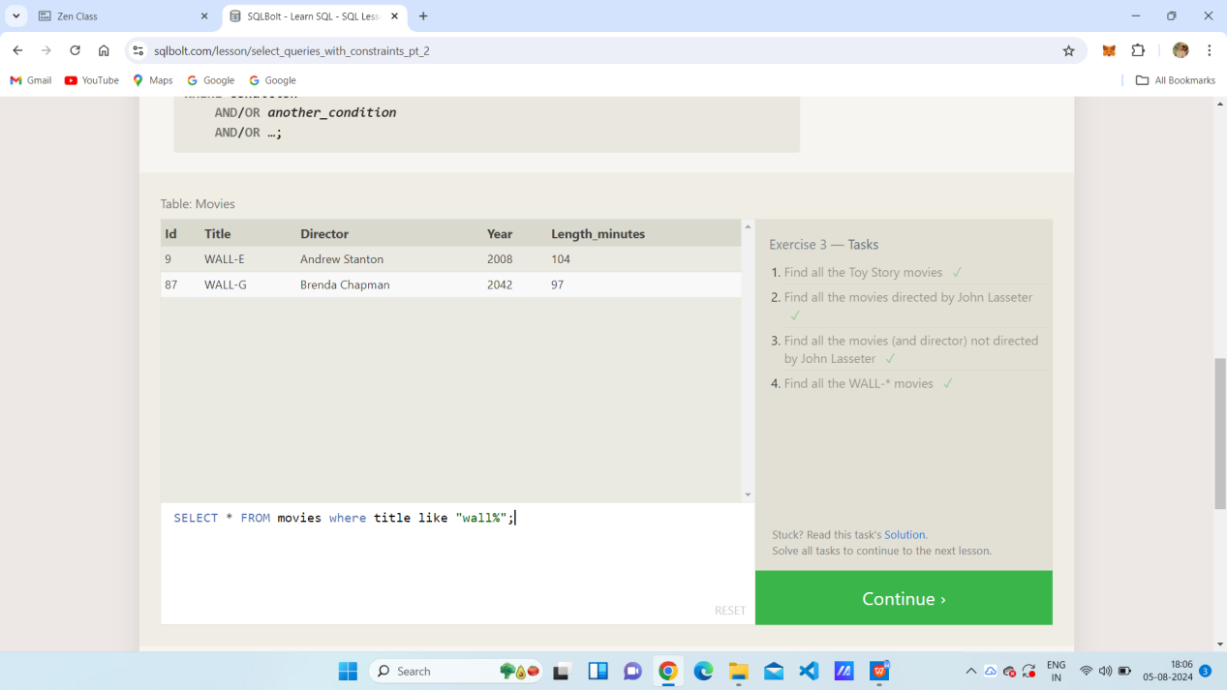

SQL Lesson 4: Filtering and sorting Query results

1. SELECT distinct director FROM movies order by director asc;
2. SELECT * FROM movies order by year desc limit 4 ;
3. SELECT * FROM movies order by title asc limit 5 ;
4. SELECT * FROM movies order by title asc limit 5 offset 5 ;

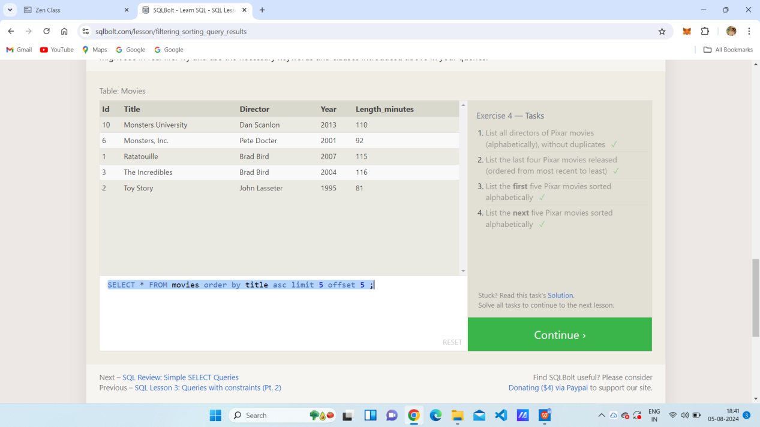

SQL Review: Simple SELECT Queries

1. select city, population from north_american_cities where country = "Canada";
2. select city , latitude from North_american_cities where country = "United States" order by latitude desc;
3. SELECT city, longitude FROM north_american_cities WHERE longitude < -87.629798 ORDER BY longitude ASC;
4. select city,population from North_american_cities where country = "Mexico" order by population desc

limit 2;

1. select city, population from north_american_cities where country LIKE "United States" order by population desc limit 2 offset 2;

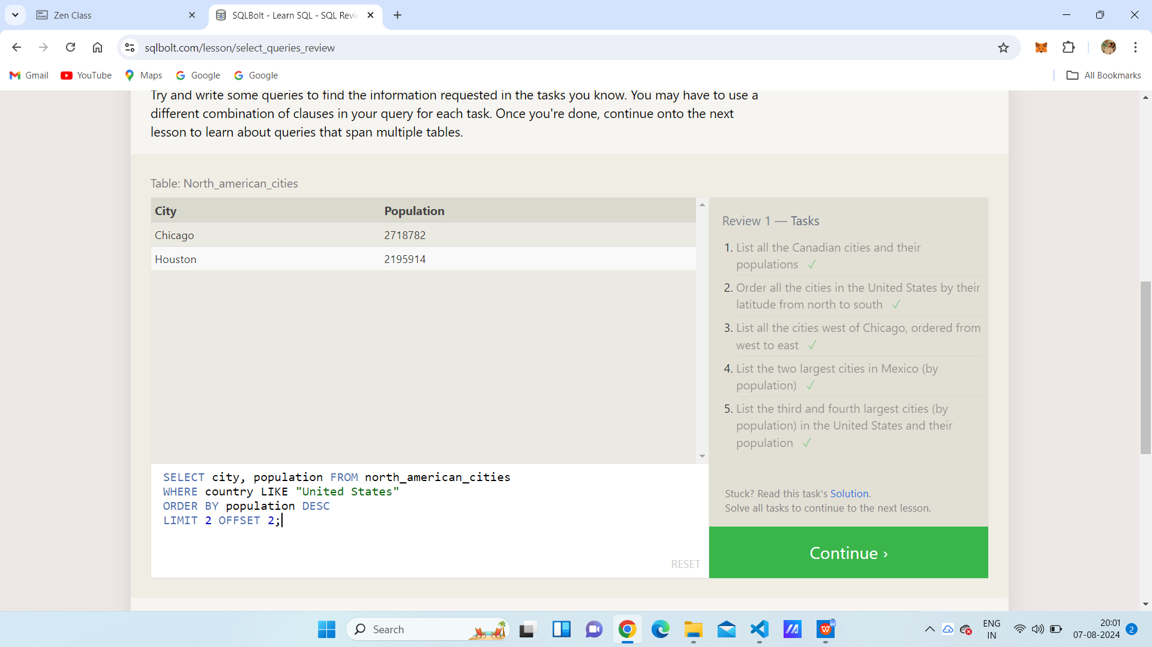

SQL Lesson 6: Multi-table queries with JOINs

1. SELECT title,domestic_sales,international_sales FROM movies join boxoffice on id = movie_id;
2. SELECT title,domestic_sales,international_sales FROM movies join boxoffice on id = movie_id where domestic_sales<international_sales;
3. SELECT title,rating FROM movies join boxoffice on id = movie_id order by rating desc;

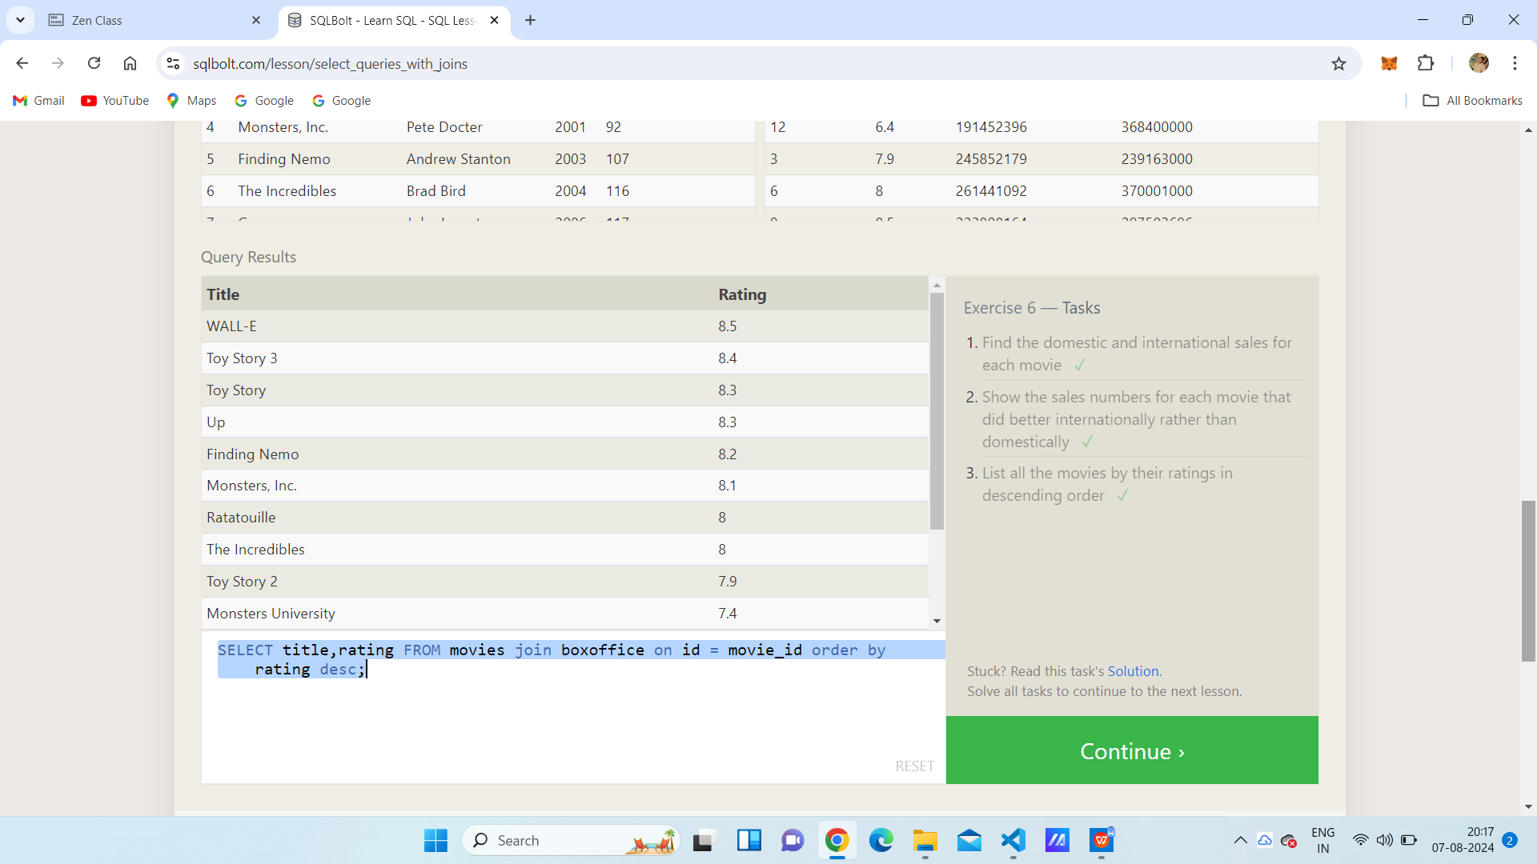

SQL Lesson 7: OUTER JOINs

1. SELECT distinct building FROM employees;
2. SELECT * FROM buildings;
3. SELECT distinct building_name , role FROM buildings left join employees on building_name = building;

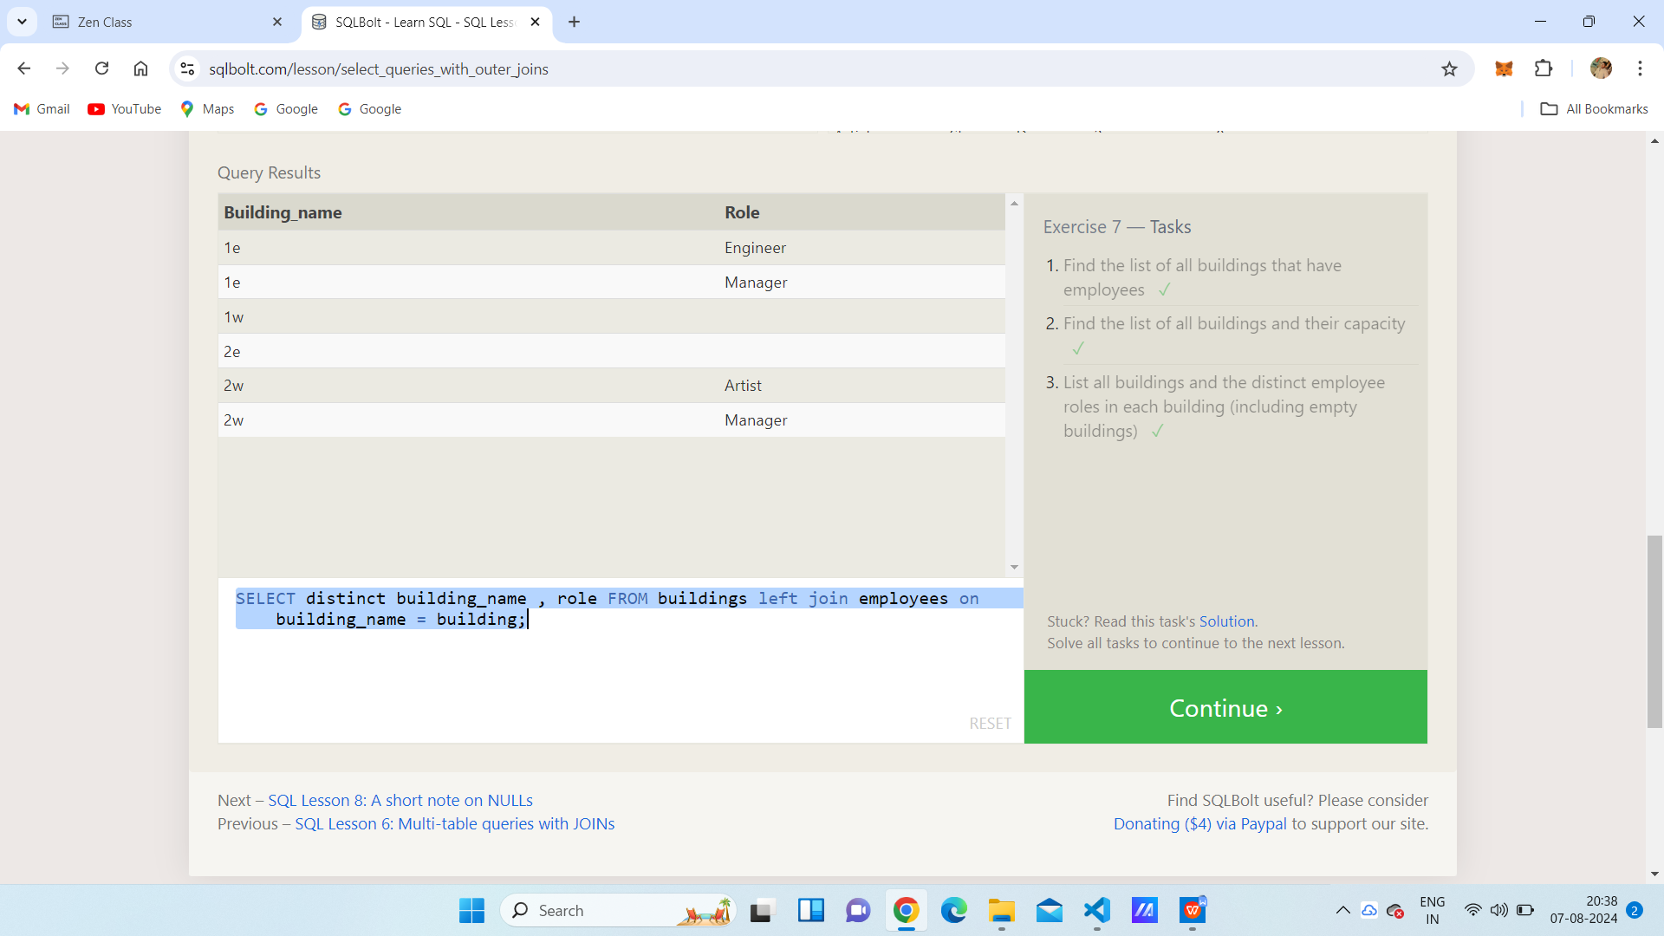

SQL Lesson 8: A short note on NULLs

1. select name, role from employees where building is null;
2. SELECT distinct building_name FROM buildings left join employees on building_name = building where role is null;

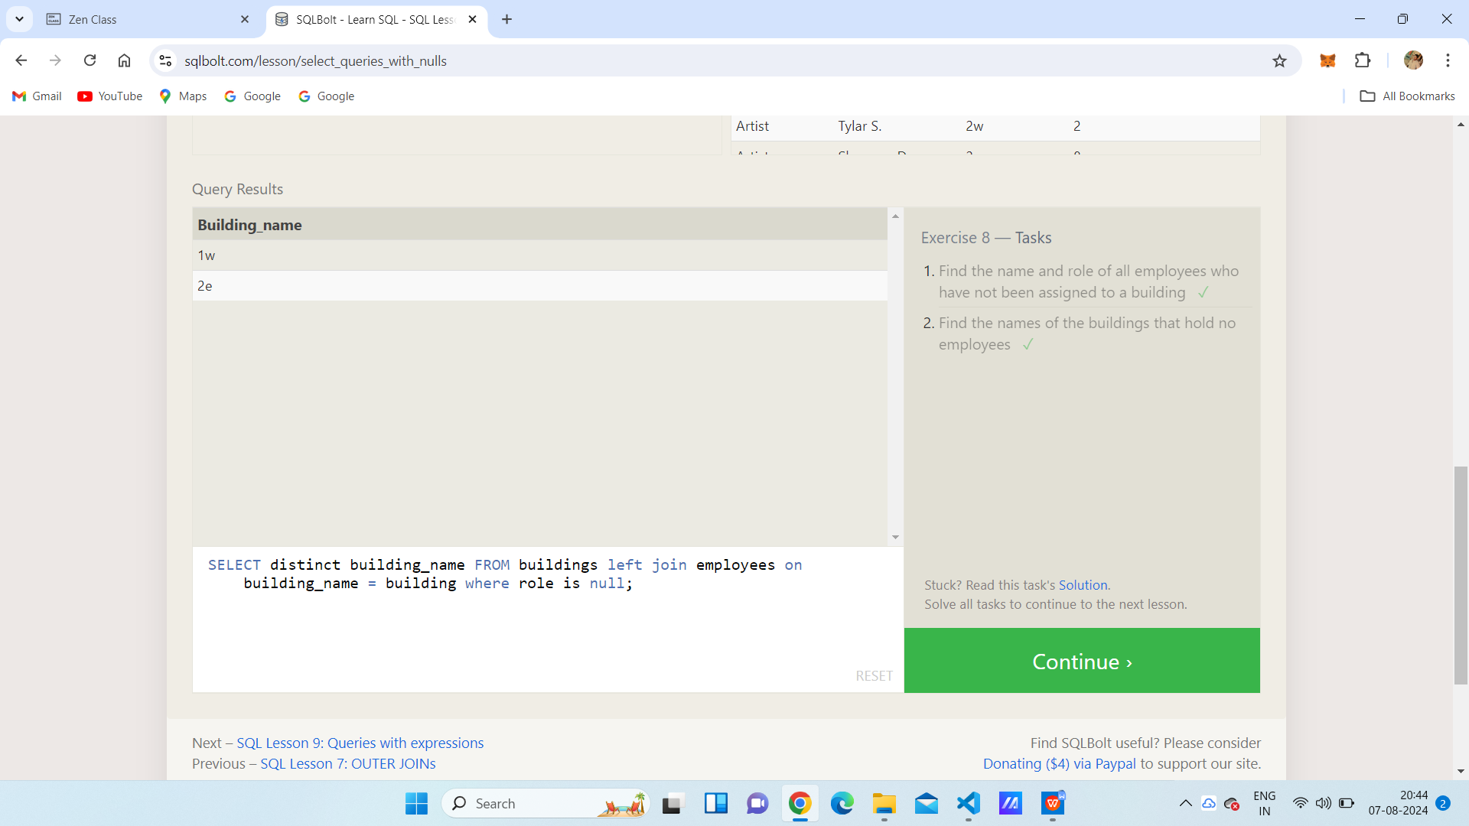

SQL Lesson 9: Queries with expressions

1. SELECT title, (domestic_sales + international_sales) / 1000000 as gross_sales_millions FROM movies join boxoffice on movies.id = boxoffice.movie_id;
2. SELECT title, rating * 10 as rating_percent FROM movies JOIN boxoffice on movies.id = boxoffice.movie_id;
3. SELECT title, year FROM movies where year % 2 = 0;

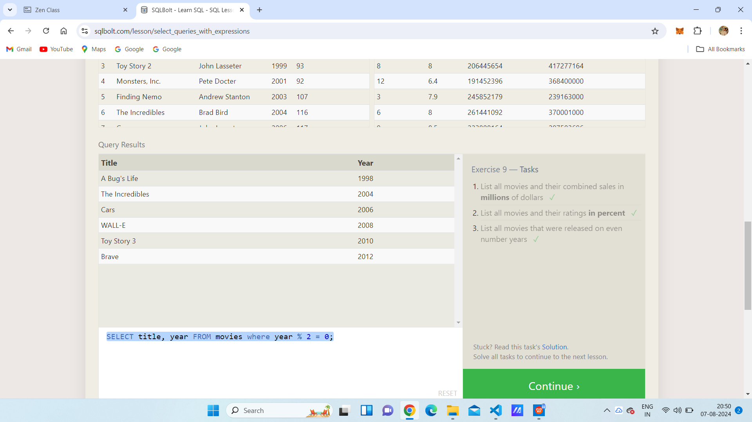

SQL Lesson 10: Queries with aggregates (Pt. 1)

1. SELECT max(years_employed) as Maximum_years-employed from employees;
2. SELECT role, avg(years_employed) as Average_years_employed FROM employees group by role;
3. SELECT building, sum(years_employed) as Total_Years_employed FROM employees group by building;

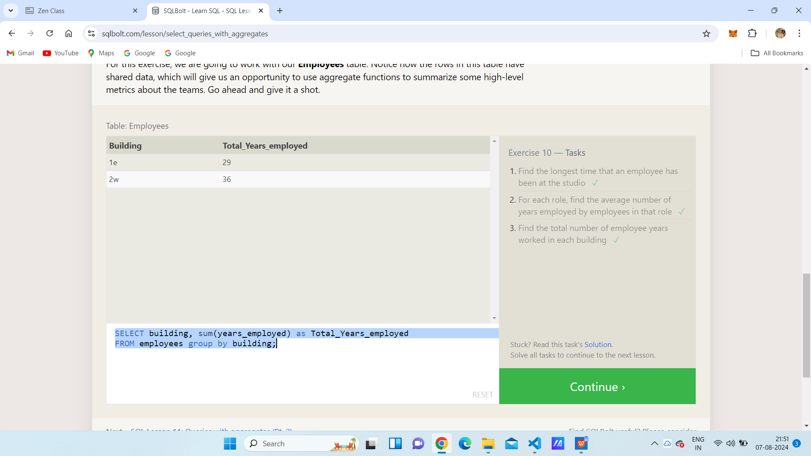

SQL Lesson 11: Queries with aggregates (Pt. 2)

1. select role , count(*) as Number_of_artist from employees where role="Artist";
2. SELECT role, COUNT(*) as number_of_employees FROM employees group by role;
3. SELECT role, sum(years_employed) FROM employees group by role having role = "Engineer";

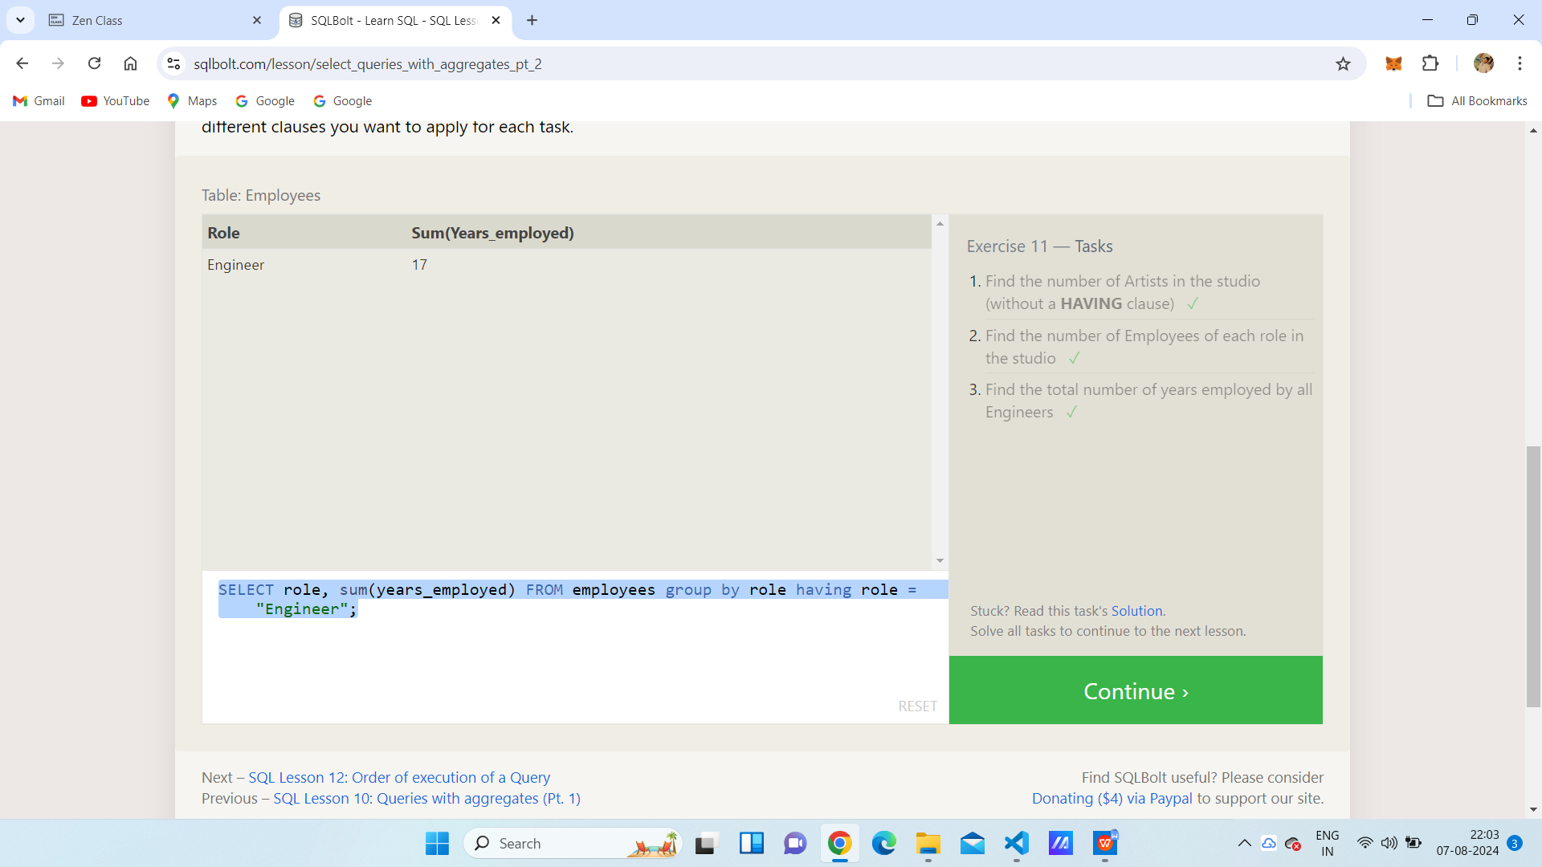

SQL Lesson 12: Order of execution of a Query

1. SELECT director, count(id) as Num_movies_directed FROM movies group by director;
2. SELECT director, SUM(domestic_sales + international_sales) as Cumulative_sales_from_all_movies from movies inner join boxoffice on movies.id = boxoffice.movie_id group by director;

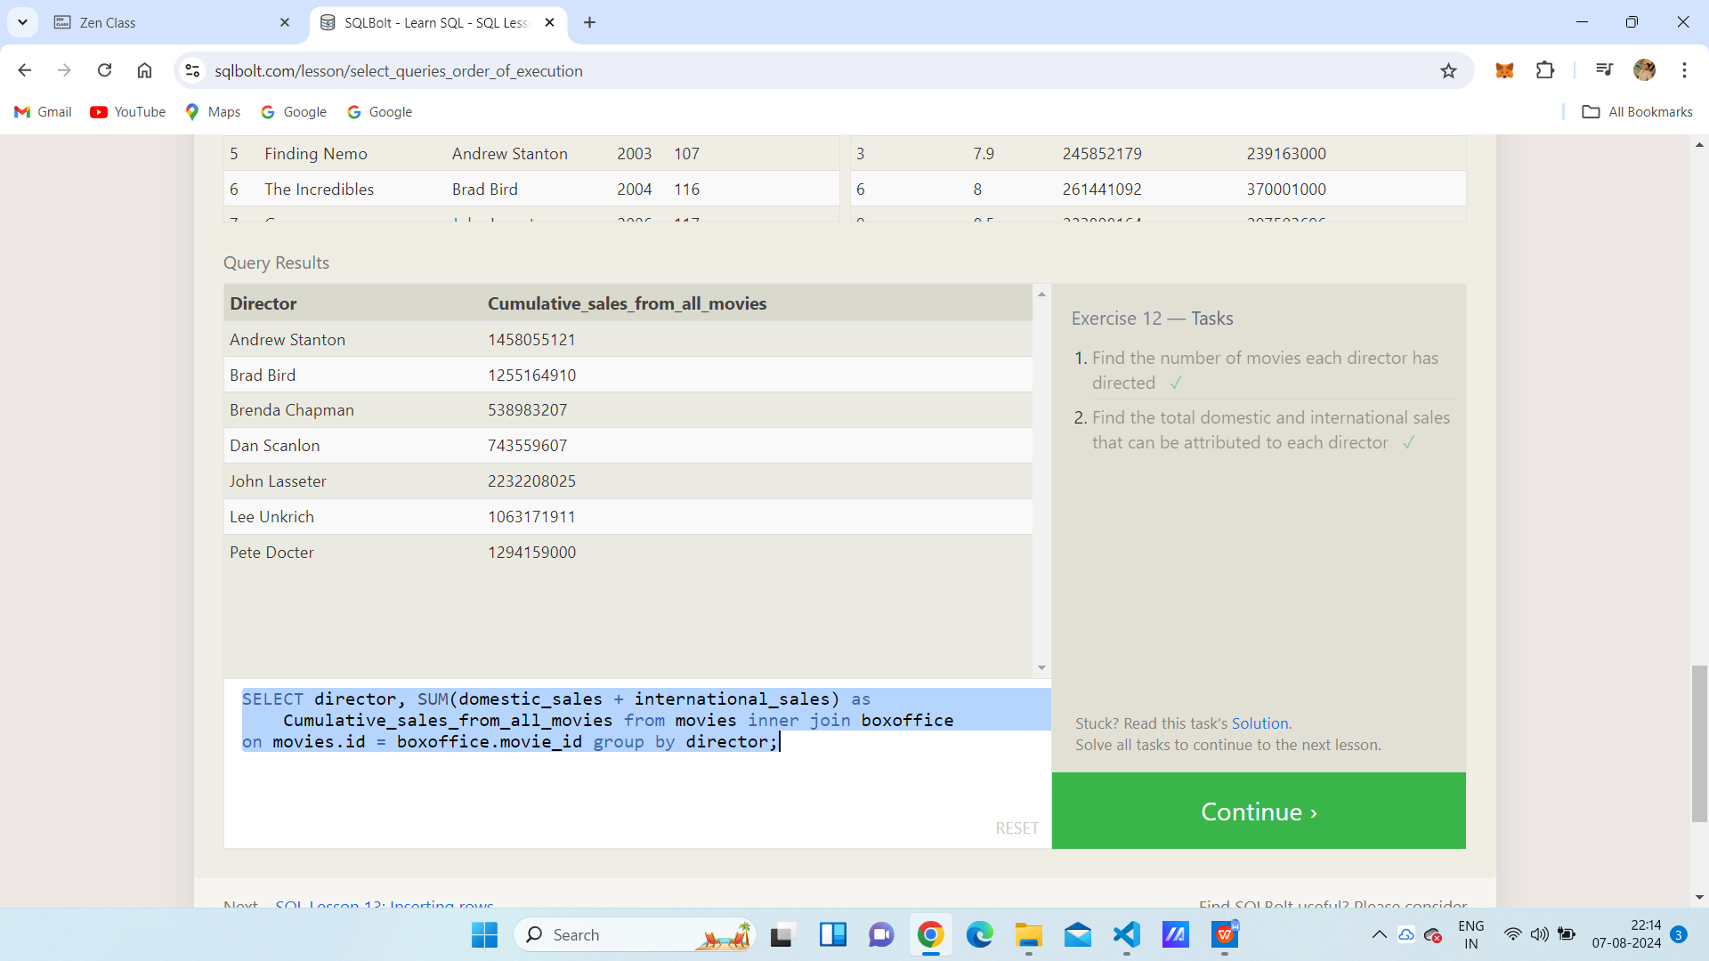

SQL Lesson 13: Inserting rows

1. Insert into movies values(4,”Toy Story 4”,”John Lasseter”,1995,85);
2. insert into boxoffice values(4,8.7,340000000,270000000);

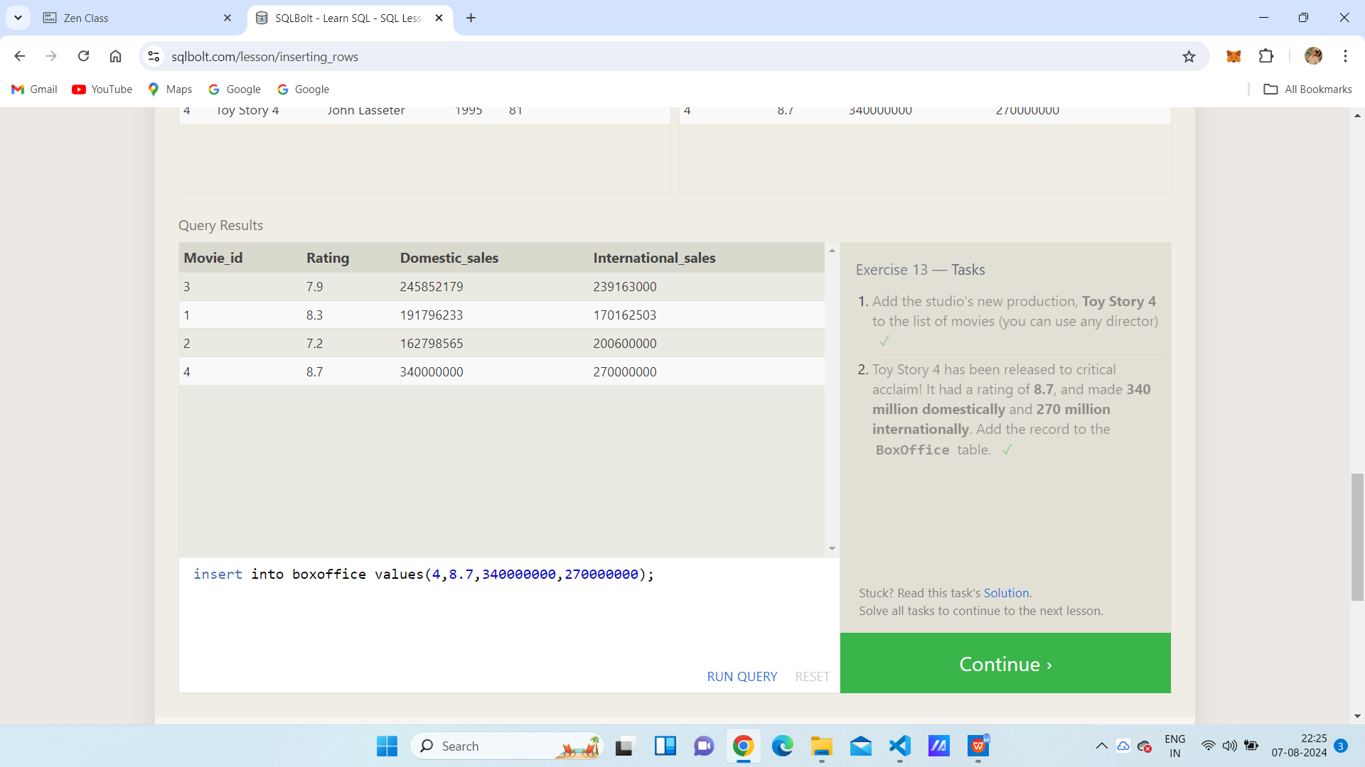

SQL Lesson 14: Updating rows

1. UPDATE movies set director = "John Lasseter" where id = 2;
2. update movies set year = 1999 where id = 3;
3. update movies set title = "Toy Story 3", director = "Lee Unkrich" where id = 11;

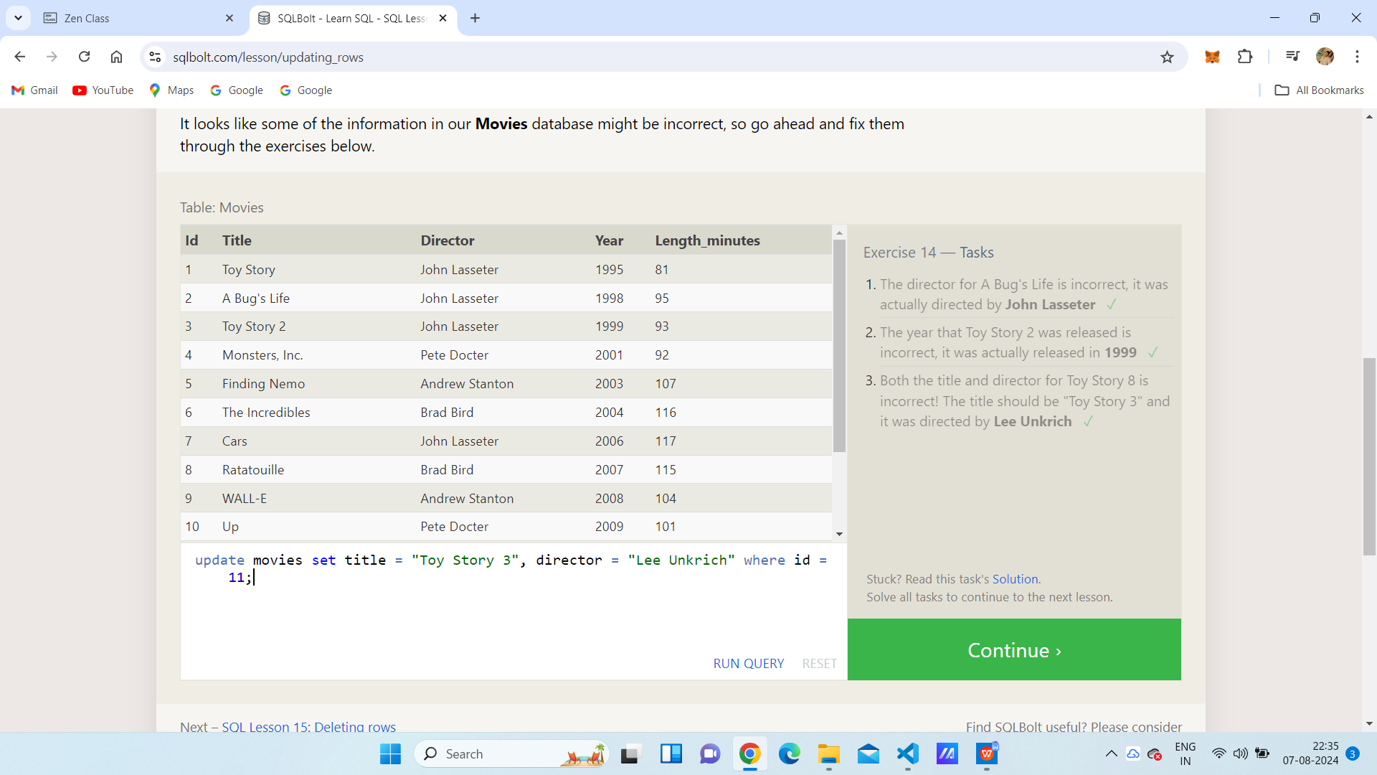

SQL Lesson 15: Deleting rows

1. delete from movies where year < 2005;
2. delete from movies where director = "Andrew Stanton";

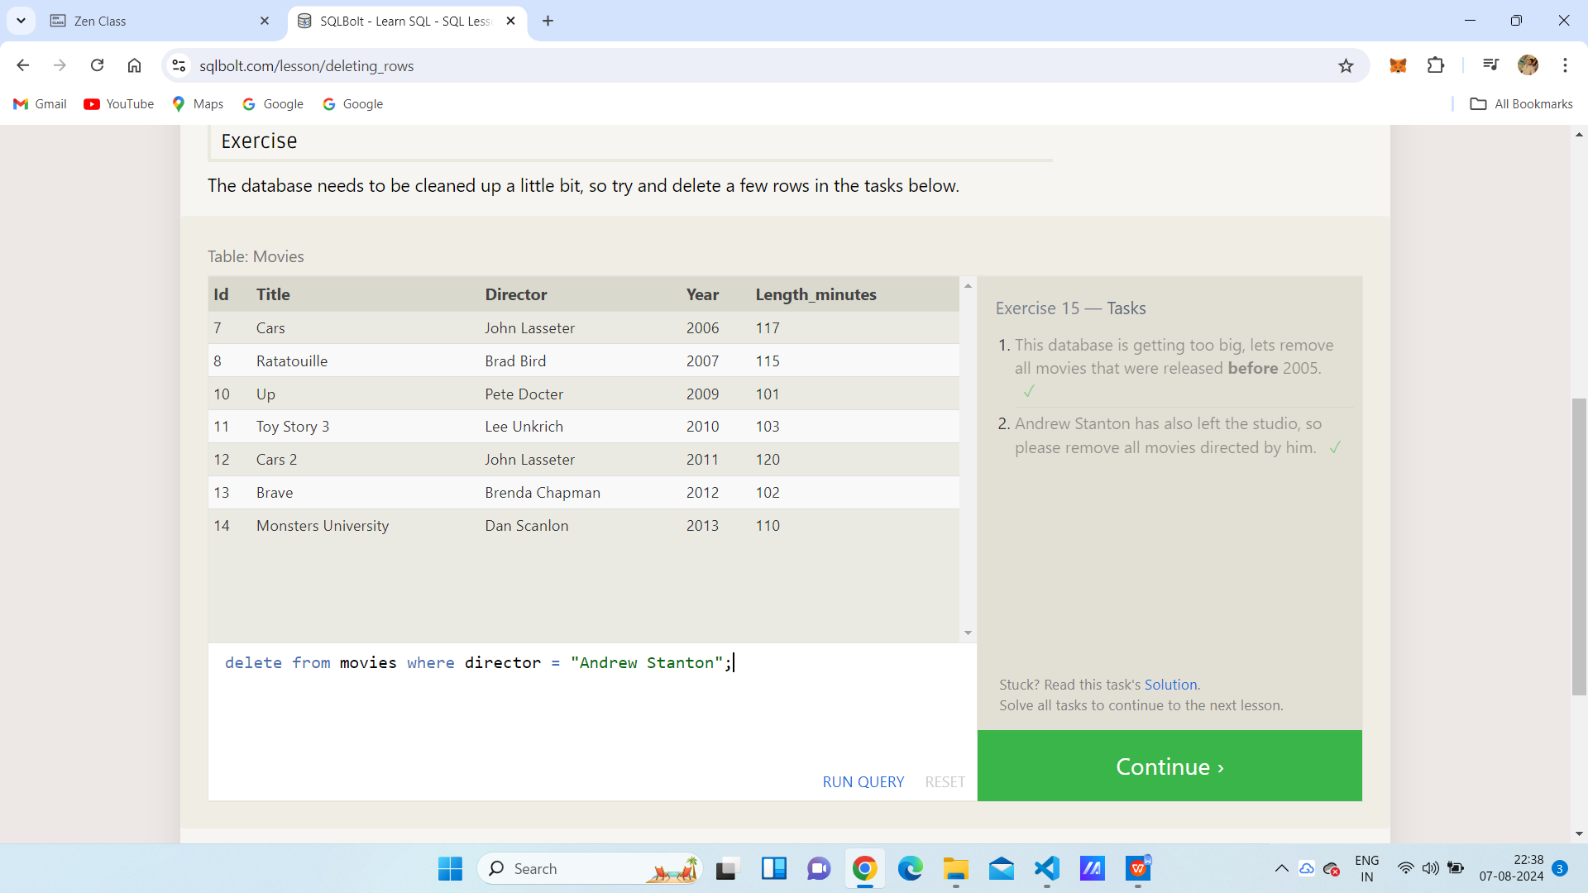

SQL Lesson 16: Creating tables

1.CREATE TABLE Database (

Name TEXT,

Version FLOAT,

Download_count INTEGER

);

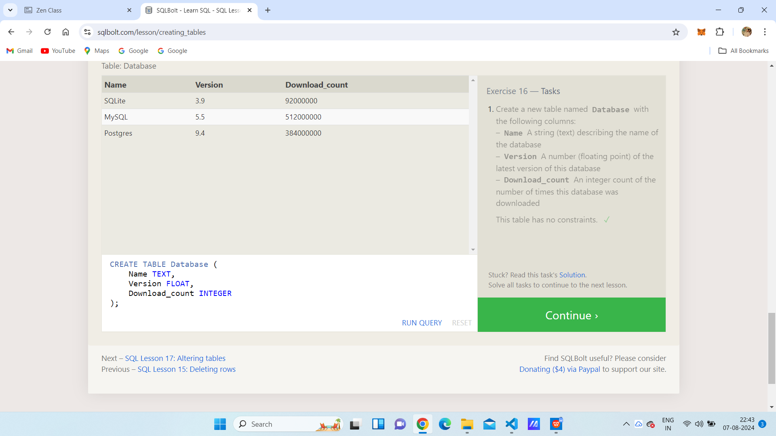

SQL Lesson 17: Altering tables

1. Alter table movies add Aspect_ratio Float;
2. alter table movies add Language Text Default English;

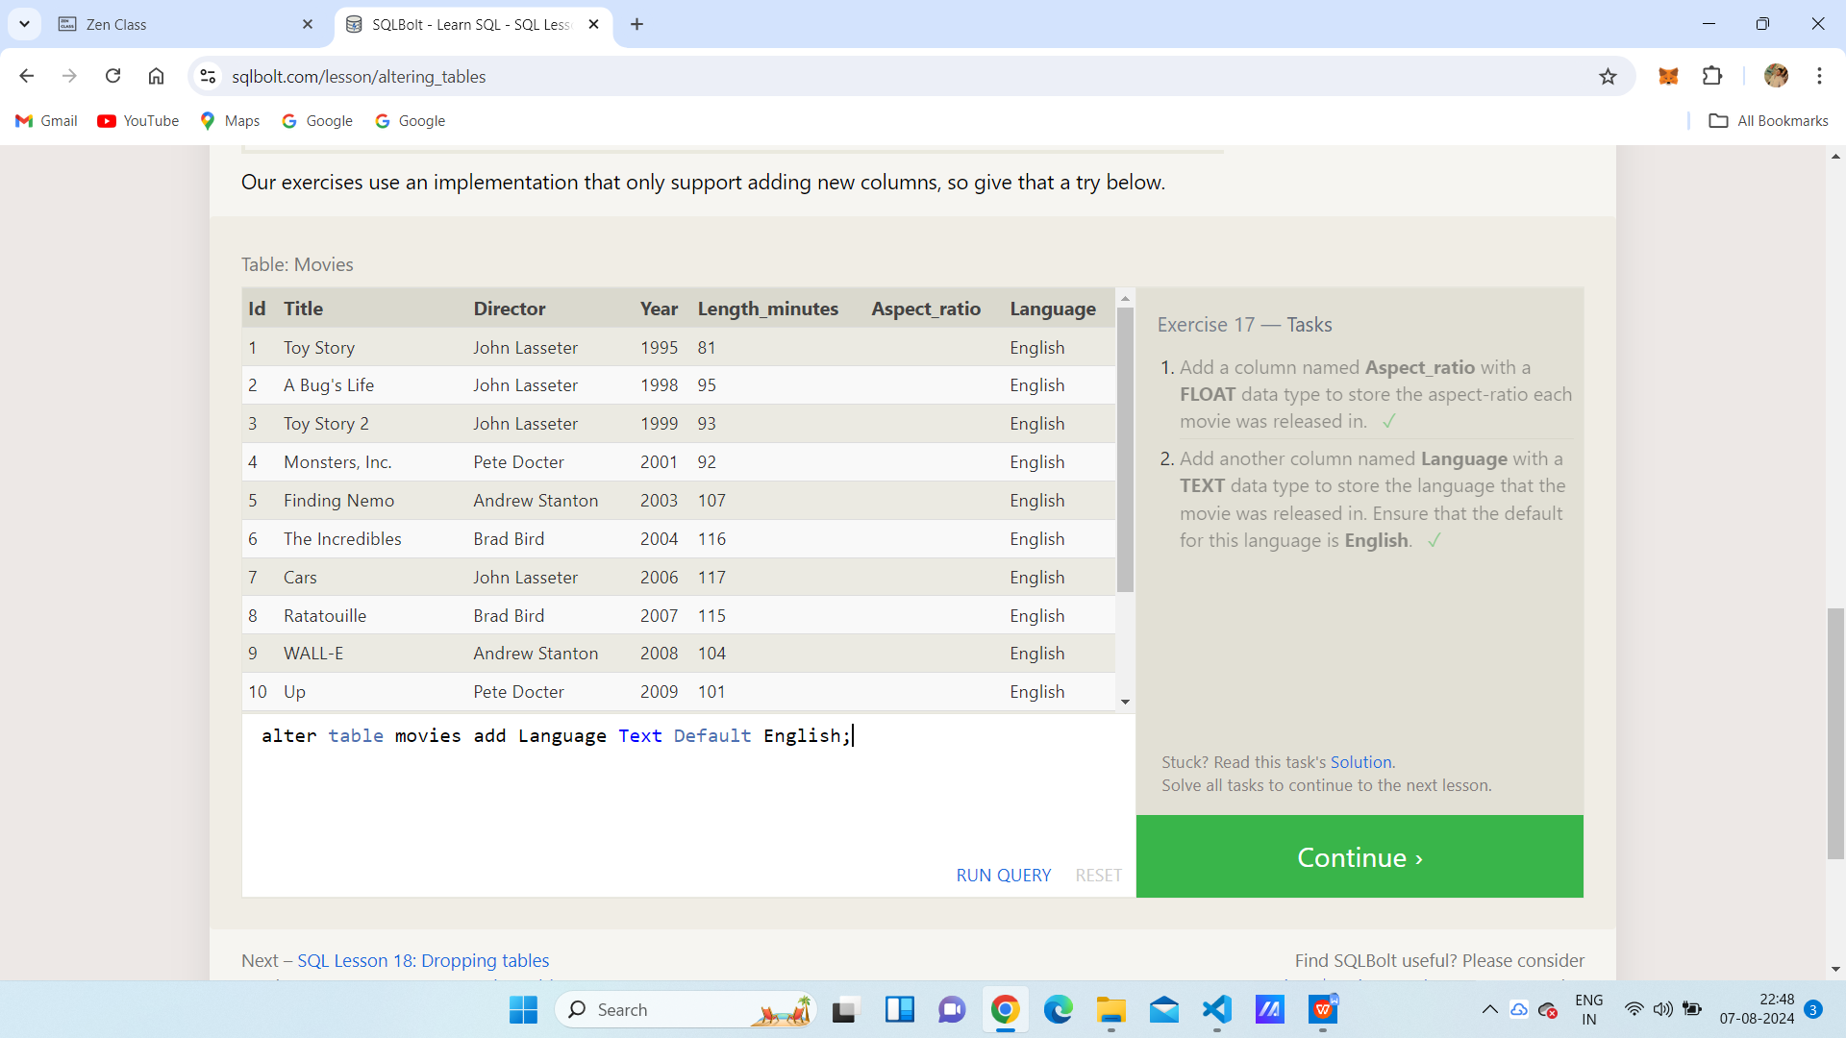

SQL Lesson 18: Dropping tables

1. Drop table Movies;
2. Drop table boxoffice;

